**Applied Statistical Methods**

**Digital Assignment 2**

By MoeenUl Islam

Roll no (21MCA0269)

**Write the R-code for the following:**

1. **The following data represents the I.Q scores of 10 mothers and their eldest daughters.**

|  |  |  |  |  |  |  |  |  |  |  |
| --- | --- | --- | --- | --- | --- | --- | --- | --- | --- | --- |
| **Mother’s I.Q (x)** | **135** | **127** | **124** | **120** | **115** | **112** | **104** | **96** | **94** | **85** |
| **Daughter’s I.Q (y)** | **121** | **131** | **112** | **115** | **99** | **118** | **106** | **89** | **92** | **90** |

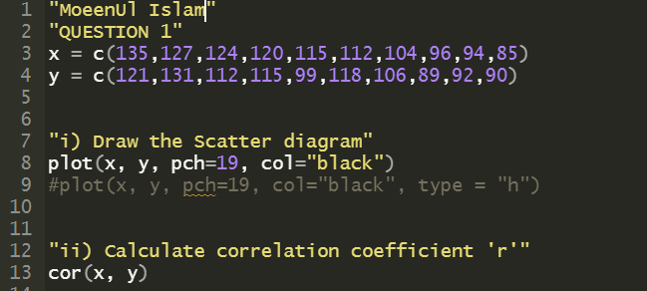

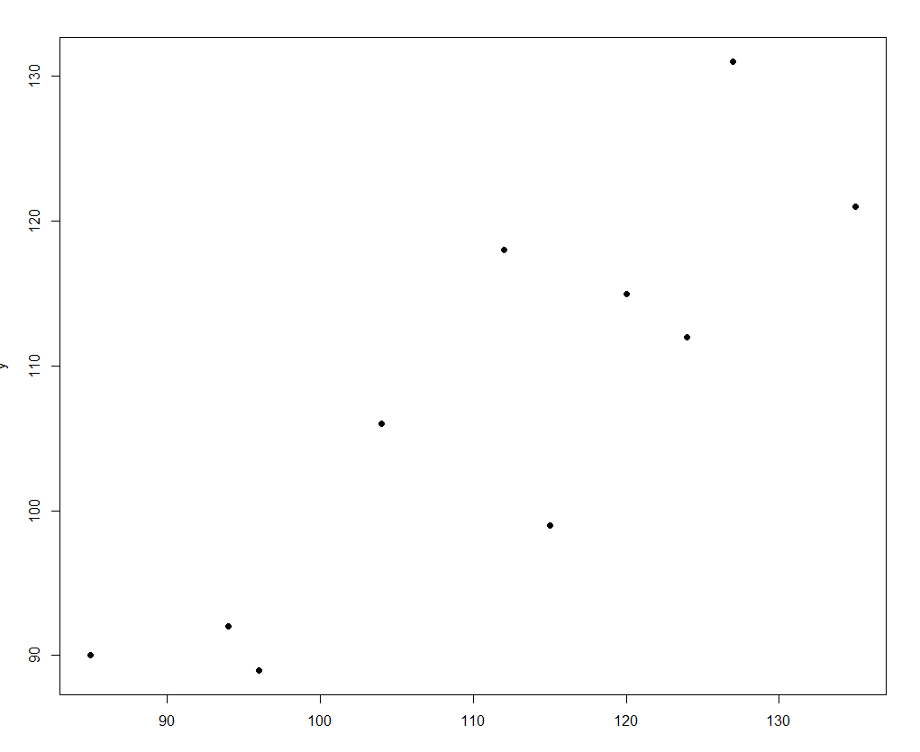



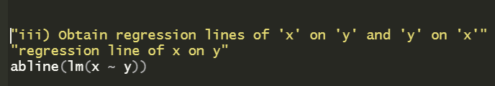

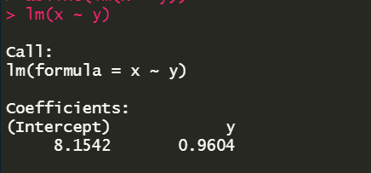

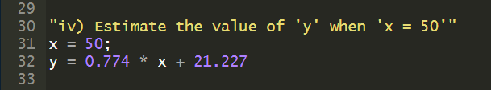

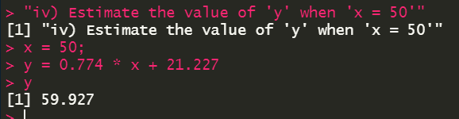

1. **Calculate the correlation coefficient between X and Y and comment on their relationship**

|  |  |  |  |  |  |  |
| --- | --- | --- | --- | --- | --- | --- |
| **X** | **1** | **3** | **4** | **5** | **7** | **8** |
| **Y** | **2** | **6** | **8** | **10** | **14** | **16** |

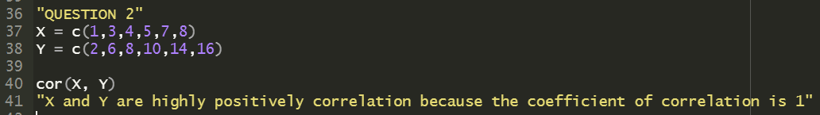



X and Y are highly positively correlated because the coefficient of correlation is 1

1. **The grades of a class of 9 students on a midterm report (x) and on the final examination (y) are as follows:**

|  |  |  |  |  |  |  |  |  |  |
| --- | --- | --- | --- | --- | --- | --- | --- | --- | --- |
| **X** | **77** | **50** | **71** | **72** | **81** | **94** | **96** | **99** | **67** |
| **Y** | **82** | **66** | **78** | **34** | **47** | **85** | **99** | **99** | **68** |

